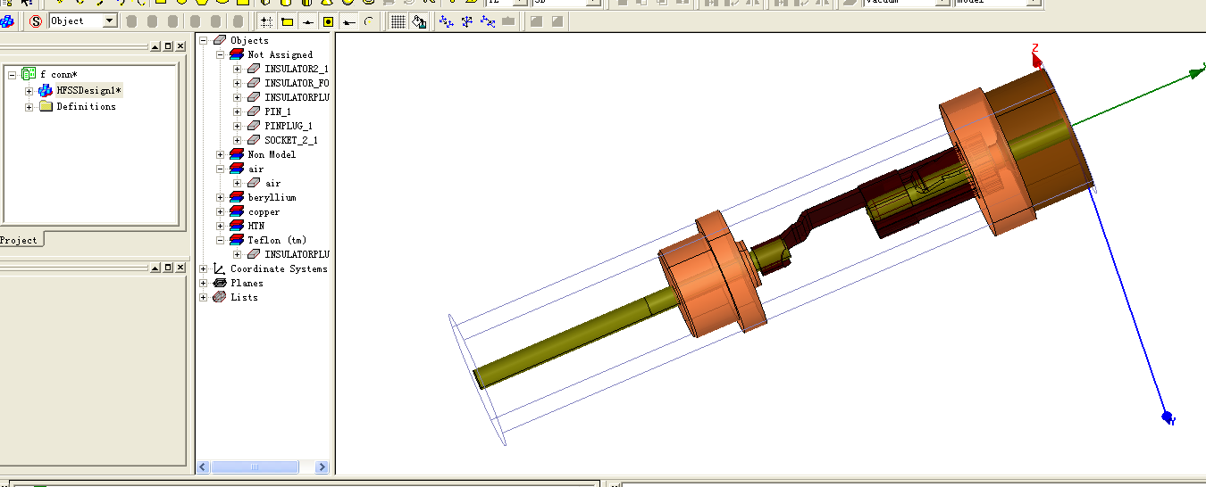

f conn (D:/hfss excit/F CONN/)
HFSSDesign1
[error] Objects "INSULATOR_FONT" and "SOCKET_2" intersect. (9:36 下午 九月 07, 2013)
[error] Objects "INSULATOR_FONT" and "SOCKET_2_1" intersect. (9:36 下午 九月 07, 2013)
[error] Objects "SOCKET_2" and "PIN" intersect. (9:36 下午 九月 07, 2013)
[error] Objects "SOCKET_2" and "INSULATOR_FONT_1" intersect. (9:36 下午 九月 07, 2013)
[error] Objects "SOCKET_2" and "PIN_1" intersect. (9:36 下午 九月 07, 2013)
[error] Objects "PIN" and "SOCKET_2_1" intersect. (9:36 下午 九月 07, 2013)
[error] Objects "INSULATOR_FONT_1" and "SOCKET_2_1" intersect. (9:36 下午 九月 07, 2013)
[error] Objects "PIN_1" and "SOCKET_2_1" intersect. (9:36 下午 九月 07, 2013)
[error] No material is assigned for "INSULATOR_FONT_1". (9:36 下午 九月 07, 2013)
[error] No material is assigned for "INSULATORPLUG_1". (9:36 下午 九月 07, 2013)
[error] No material is assigned for "PIN_1". (9:36 下午 九月 07, 2013)
[error] No material is assigned for "SOCKET_2_1". (9:36 下午 九月 07, 2013)
[error] Boundary Setup: An excitation must be defined in order to solve driven problems. (9:36 下午 九月 07, 2013)
[error] Solution Setup: No solution setups have been created. (9:36 下午 九月 07, 2013)

